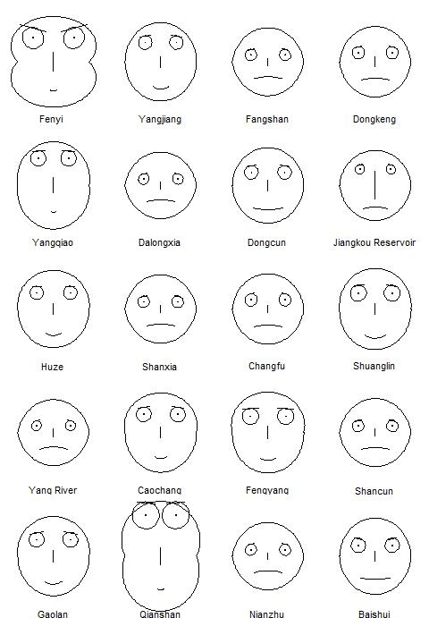

This data-visualization piece (Refer to the attachment) shows 2010 land use information among 20 subzones of Fenyi County (China). As creatures do everything on the land, land use and land cover play a vital role in our life. Hence, I selected this environmental issue. The classification of land use type refers to Chinese Guidelines for Land Use Status (GTB21010-2007). Chernoff faces were used to represent and to visually differentiate the similarities of land use information. And “faces2” in R package “TeachingDemos” is used to make the plot. There are nine facial characteristic parameters and their corresponding relations to land use types:

*"height of face" - "total area"*

*"curvature of mouth" - "agricultural land"*

*"width of eyebrows" - "garden land"*

*"size of eyes" - "forest"*

*"width of top half of face" - "grassland"*

*"width of bottom half of face" - "built-up"*

*"angle of eyebrows" - "transport"*

*"length of nose" - "water"*

*"height of eyes" - "other type"*

Except the curvature of mouth which is between -9 to 9, each parameter is represented by a number between 0 and 1 and their corresponding relation are positive, e.g.: the inside steeper the angle of eyebrow is, the larger area of transport land the subzone has. As people visually prioritize faces and acutely discern variations in facial expression. Mapping data into faces would provide a better understanding of complex data sets1. Thus, it is easier and more interesting for readers to find the land use information like similarities among subzones. For example, Fengyang and Shuanglin are similar with each other, and the land use of Fangshan, Dongkeng, Changfu, Shancun and Nianzhu could be put into one cluster. Additionally, other details, like which subzone owns maximum area of certain land use type, can be observed.